Experiment 10

Aim: To perform a 90-degree clockwise rotation of an image using Python and OpenCV.

Algorithm:
- Import the OpenCV library.
- Read the input image.
- Rotate the image by 90 degrees clockwise using cv2.ROTATE_90_CLOCKWISE.
- Display the original and rotated images.
- Wait for a key press and close all windows.

Program
import cv2
img = cv2.imread("image.jpg")
rotated = cv2.rotate(img, cv2.ROTATE_90_CLOCKWISE)
cv2.imshow("Original Image", img)
cv2.imshow("Rotated Image", rotated)
cv2.waitKey(0)
cv2.destroyAllWindows()
Output
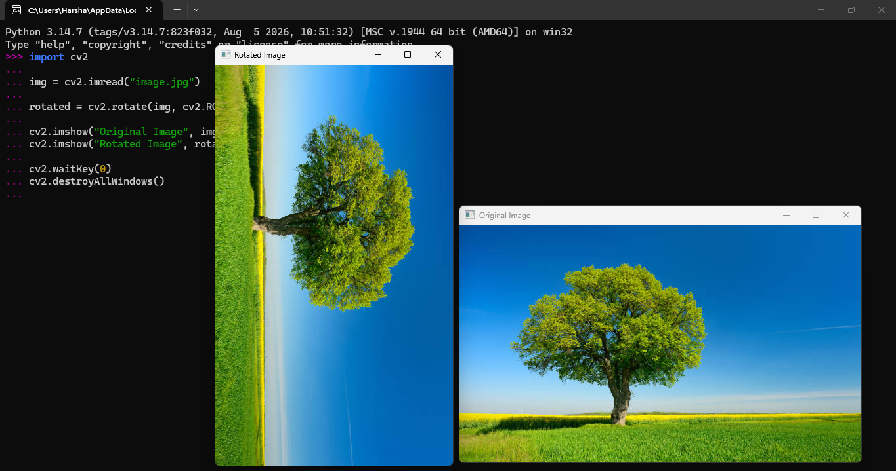

Result: The image was successfully rotated by 90 degrees clockwise using OpenCV.

